36.56: a) 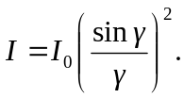The maximum intensity occurs when the derivative of the intensity function with respect to is zero.
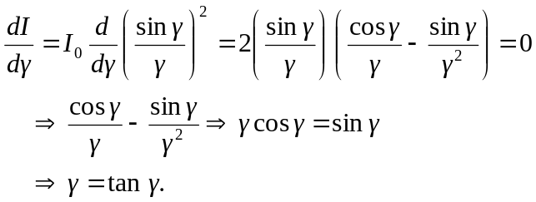

b)

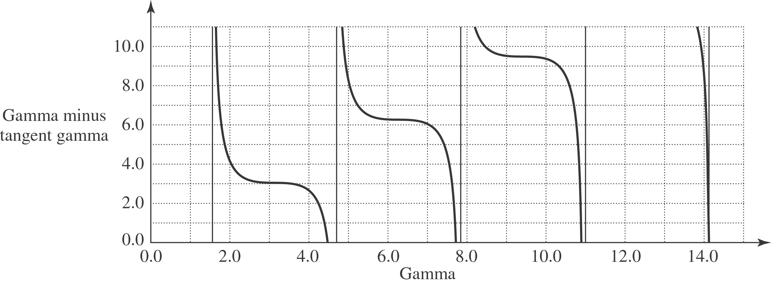

The graph above is a plot of f() = 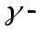tan. So when it equals zero, one has an intensity maximum. Getting estimates from the graph, and then using trial and error to narrow in on the value, we find that the three smallest -values are = 4.49 rad 7.73 rad, and 10.9 rad.

